CSU8RT10186BA

- 产品Bonding图说明：

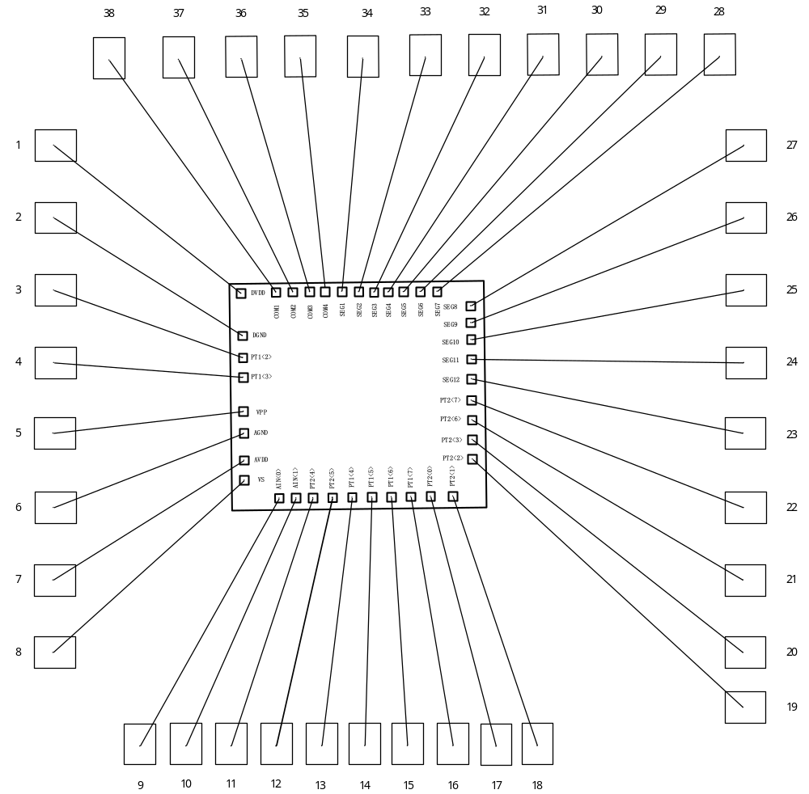

- 产品管脚描述及坐标位置
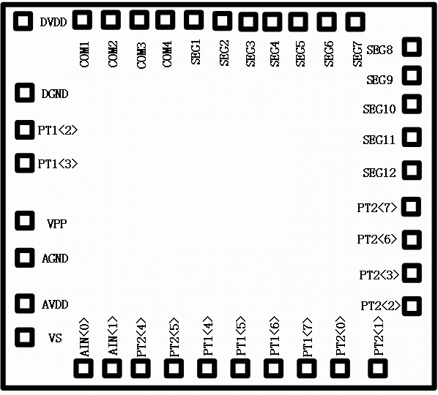

PAD序号 | PAD Name | X,Y（单位：um）
1 | DVDD | 53,1155
2 | DGND | 53,955
3 | PT1.2/XIN | 53,853
4 | PT1.3/XOUT | 53,749.4
5 | VPP | 50,550
6 | AGND | 50,450
7 | AVDD | 50,233
8 | VS/REF | 53,128
9 | AIN0 | 151,53
10 | AIN1 | 251,53
11 | PT2[4]/ RX /INT1 | 426,53
12 | PT2[5]/ TX /INT1 | 526,53
13 | PT1[4]/LPD | 626,53
14 | PT1[5] /INT0 | 726,53
15 | PT1[6] | 826,53
16 | PT1[7] | 926,53
17 | PT2[0] /RX /INT0 | 1026,53
18 | PT2[1] /TX /INT1 | 1126,53
19 | PT2[2] | 1257,196
20 | PT2[3] /BZ | 1257,296
21 | PT2[6]/ SEG14 | 1257,396
22 | PT2[7] /BZ / SEG13 | 1257,496
23 | SEG12 | 1257,606
24 | SEG11 | 1257,712
25 | SEG10 | 1257,815
26 | SEG9 | 1257,920
27 | SEG8 | 1257,1026
28 | SEG7 | 1130,1157
29 | SEG6 | 1033,1157
30 | SEG5 | 938,1157
31 | SEG4 | 842,1157
32 | SEG3 | 745,1157
33 | SEG2 | 650,1157
34 | SEG1 | 553,1157
35 | COM4 | 455,1157
36 | COM3 | 360,1157
37 | COM2 | 264,1157
38 | COM1 | 169,1157

